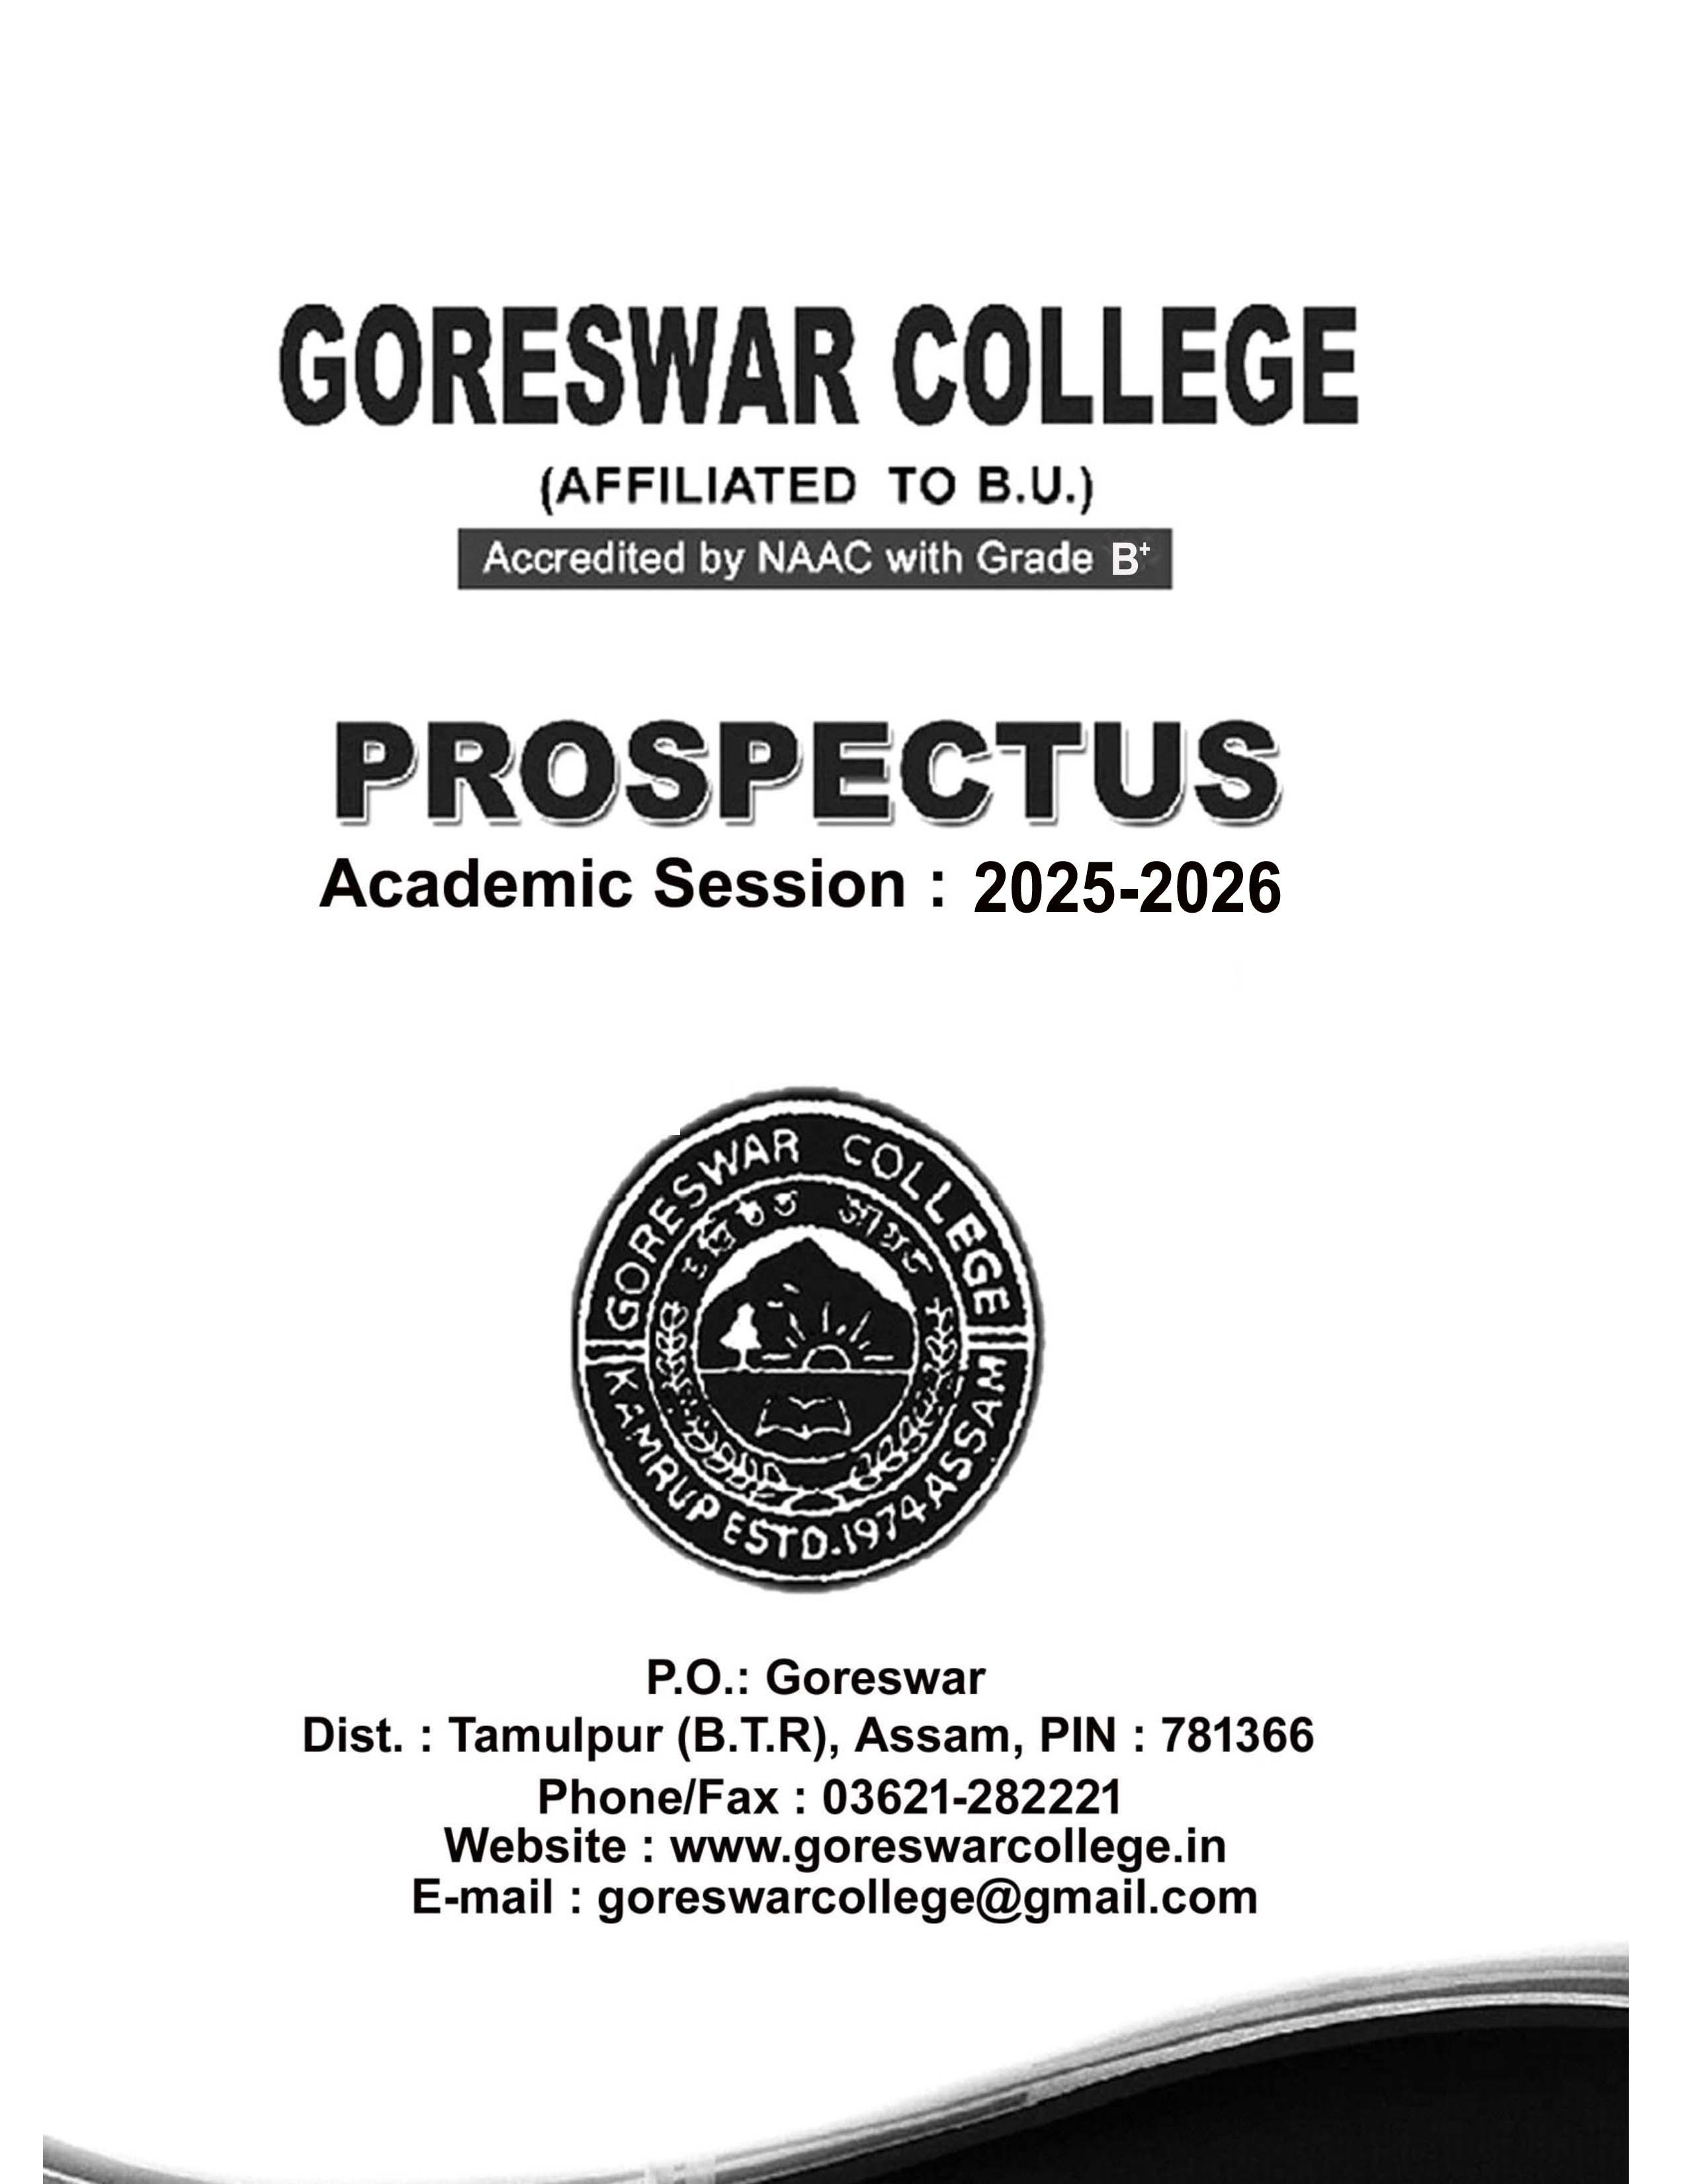

GORESWAR COLLEGE PROSPECTUS


CONTENTS

Page
Message from the Principal 01
About the college 02
Academic Programmes 02
H.S.Arts
H.S.Commerce
B.A.Honours
B.A. Regular B.Com.Honours B.Com. Regular B.Sc. Honours B.Sc. Regular CBCS Course
Distance Education 07
Some Important points of 07
Semester system
Admission Procedure 10
Rules and Regulations of the College 11
General information 12
College Premises & Facilities 13
Awards and Incentives 14
Cells and Committees 14
The Governing Body 16
Faculty 17
Office Staff 19
Fees Structure (Arts) 20
Fees Structure (Commerce) 21
Fees Structure (Science) 22
Annexure I 23

COLLEGE AT A GLANCE

Name : Goreswar College
Grade : B+ (Accrediated by NAAC)
Address : P.O.Goreswar, Dist. Tamulpur,B.T.R. Assam. PIN 781366
Year of Estd. : 1974
Area : 34875 sqm.
Principal : Dr. Pramod Medhi,M.Sc.Ph.D.FEHT Vice- Principal : Mr. Umesh Baro, MA (Triple), B.Ed.
Hindi Prabin, Bodo,(Cert. & Diploma)
Academic In-Charge: Dr. Ramen Medhi, M.A, B.Ed., Ph.D
Phone No. : 03621-282221
Website : www.goreswarcollege.ac.in
e-mail : goreswarcollege@gmail.com Stream : Arts, Science, Commerce
Total Departments: 18 (Arts 8, Commerce 5, Science 5) Total Sanctioned Posts: 26

College Hour: Working/Class hour – 9.00 a.m. to 5p.m
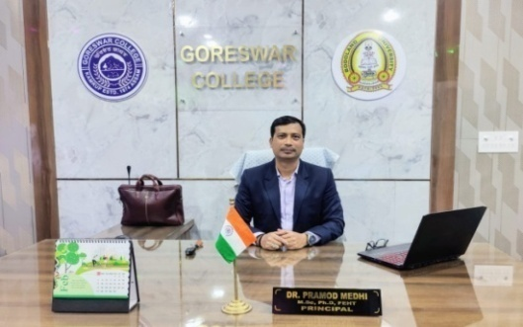 From the Principal Desk

Goreswar College, established in the year 1974 is one of the premier institutions located on the northern banks of the Brahmaputra River. The college is affiliated to Bodoland University, Bodoland Territorial Region (BTR), Assam. The college offers under graduate courses in the field of Arts, Science and Commerce. In order to accomplish our mission and vision, we are willing to undertake our best efforts.
The College aims to impart high quality of education in the three streams mentioned above. It attempts to inculcate the highest intellectual standards through rigorous academic commitment and discipline. For this purpose, the college has well-equipped departments, library facilities, science laboratories and playgrounds. In order to implement the New Education Policy(NEP),Goreswar College has been trying to develop human resource of high quality and to make students responsible citizens of the society. We are proud to have students from different ethnic backgrounds and the college boasts of possessing a culturally vibrant campus. The College carries out many extension activities such as village adoption programmes, providing relief to needy people during natural calamities, tree plantations etc.
To emphasis the importance of healthy mind among the students, we run a full- fledged counseling cell with professional counselors to look after the mental well-being of its staff, students and others take holders. We are constantly improving our selves ,in order to serve the community with the very best education and pleasant learning environment in the region. I am confident that with the support of the local community, our students, staff, alumni and well-wishers, we will continue to strive forward in our endeavor.

(Dr. Pramod Medhi, M.Sc, Ph.D, FEHT)
Principal
Goreswar College

ABOUT THE COLLEGE
Goreswar College was established in 1974 by a team of selfless and untiring social workers and lovers of education of the greater Goreswar area and with the help of Betna Siksha and Krishi Unnayan Sangha (An Education and Agricultural Development Organisation). The College was brought under deficit system of grants-in-aidin1981.Again the college was provincialised
w.e.f.1st February, 2005 by the Govt. of Assam along with ot her Deficit System of Grants- in-Aid Degree Colleges. The college has obtained inclusion under 2 (F) & 12 (B) of the UGC Act. Of 1956 vide UGC order no. F8-31/95 (CPP-I) dated 8th April,2003. At present the College has three streams-Arts, Commerce and Science. The present enrolment of the college is around 2000. At present it is under BTR (Bodoland Territorial Region). Goreswar College, thus, reflects the hopes and aspirations for Higher Education of the developing people of a geographically far-flung area to the South-East extreme of the District of Baksa. From the inception of this college, it was affiliated to Gauhati University. At present it comes under Bodoland University.

VISION:

As for its vision the college aims at imparting quality education for building a strong foundation of the nation by creating human resource of high caliber leading to national development.
Elevating the college to a PG level institution.
Expanding the research and consultancy-potential to the optimum level.
Building a full fledged sports infrastructure to complement measures for academic excellence.
Effectively utilizing the fruits of information technology in the teaching-learning experience.

Creating a better academic environment with a linkage to the society at large.

MISSION:
The following mission statements aim at translating the vision of Goreswar College into action:
To elevate the college to a centre of excellence
To include entrepreneurial/ vocational training programmes in curriculum so as to promote skill development leading to national development.
To modernize the society by using knowledge and its application as a tool for social development.
To provide right kind of leadership to the youths.
To strive to tap the ever expanding frontiers of information technology in spreading of education.

ACADEMIC PROGRAMMES:
The College has been conducting H.S. classes in Arts and Commerce under A.H.S.E.C. in response to the public demand of the area. Admission to H.S. course is open to those who

Have passed H.S.L.C under S.E.B.A. or equivalent examinations under other Boards/Councils recognized by A.H.S.E.C.

HIGHER SECONDARY COURSE

H.S.(ARTS)

Compulsory Subjects:
1. English 2. Alternative English/M.I.L.(M.I.L. includes Assamese and Bodo.),
3. Environmental Studies.

Elective Subjects:
Any four subjects (including the optional fourth one) from the following:
1. History 2.Education 3.Economics 4.Logic & Philosophy
5. Political Science 6.Advance Assamese 7.Advance Bodo 8.Mathematics
9. Swadesh Adhyayan.

Stream | No. of Seats
Arts | 300

H.S. (COMMERCE)

Compulsory Subjects:
1. English 2. Alternative English/M.I.L.(M.I.L. includes Assamese and Bodo)
3. Accountancy 4. Business Studies 5.Economics 6. Banking/Mathematics
- Environmental Studies
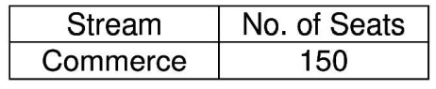
Optional Subject: Swadesh Adhyayan.

FOUR YEARS DEGREE COURSES
The College is introducting Four Years Degree Course as per NEP 2020 in Arts, Commerce and Science streams in Semester mode under Bodoland University. Admission to Degree courses is open to those who have passed H.S. or equivalent examinations of other institutions recognized by the A.H.S.E.C. or equivalent Boards. The course is divided into two Sections (A&B) in Arts, Commerce and Science streams.

UNDER GRADUATE PROGRAMMES BASED ON NEP-2020
  - 3/4 Years Programmes
    - 1Year Certificate
- Years Diploma
- Years Degree
- Years Research Enable Degree

CURRICULUM SRTUCTURE FOR FOUR YEARS UNDER GRADUATE PROGRAMME (FYUGP) BASED ON NEP-2020

Semester | Major | Minor | IDC | AEC | SEC | VAC | Internship | Summer Internship* | ADL/Disseration** | Total Credit
I | 4 | 4 | 3 | 2 | 3 | 4 |  | 4 |  | 20
II | 4 | 4 | 3 | 2 | 3 | 4 |  | 4 |  | 20
UG Certificate
III | 8 | 4 | 3 | 2 | 3 |  |  | 4 |  | 20
IV | 12 | 4 |  | 2 |  |  | 2 | 4 |  | 20
UG Diploma
V | 16 | 4 |  |  |  |  |  |  |  | 20
VI | 16 | 4 |  |  |  |  |  |  |  | 20
Bachelor Degree in the Subject
VII | 16 | 4 |  |  |  |  |  |  |  | 20
VIII | 4 | 4 |  |  |  |  |  |  | 12 | 20
Total Credit | 80 | 32 | 9 | 8 | 9 | 8 | 2 |  | 12 | 160
Bachelor Degree with Honours/ Honours and Research

SEAT CAPACITY: ARTS

Subjects Major Minor
Assamese | 70 | 400
Political Science | 70 | 400
Philosophy | 70 | 400
Nepali | - | 100
History | 60 | 300
English | 60 | 400


Prospectus

Education | 70 | 400
Economics | 60 | 300
Bodo | 80 | 300
Statistics 20 |  |  | 50

SEAT CAPACITY: COMMERCE

Subjects Major Minor
Human Resource Management 30 150
Marketing Management 30 150
Finance 30 150
Accountancy 30 150

SEATCAPACITY:SCIENCE

Subjects Major Minor
Computer Science 50 200
Botany 50 200
Zoology 50 200
Physics 50 200
Mathematics 50 150
Chemistry 50 200

ADD ON COURSES

COURSE NAME DEPARTMENTS/STREAM CO-ORDINATIOR

- Yoga Foundation Course Philosophy Dr. Jahirul Hussain
- Creative Writing English Mrs Runa moni Boro
- Fundamentals of History Mrs. Juri Deka
Archaeological Tourism
- Human Rights in India Political Science Dr. Bandana Sarma
- Tally Commerce Mr. Raju Dasgupta
- Basic Statistics for Science Commerce Mrs Bibha Rani and Humanities Talukdar
- Certificates in Micro-Finance Commerce Mr. Banjit Barman and Rural Development

- DTP in Assamese Assamese Dr. Ramen Medhi
- Comparative Literature Bodo Mr. Umesh Baro
- Travel and Tourism Economics Dr. Prithwiraj Swargiary
- Aquaculture Zoology Mrs. Dolly Bala Brahma
- Mushroom Cultivation Botany Ms. Himashri Deka

DISTANCE EDUCATION:
The College provides various courses of the Distance mode under Study centre of K K Handiqui State Open University such as BA, M.A. in three subjects i.e. Assamese, Education and Political Science.

ADMISSION PROCEDURE 2025-2026
H.S./Degree Admission process for the new Academic Session 2025-26 will start immediately after the declaration of HSLC/AHSEC results. Last date of submission of application form will be announced after the declaration of HSLC/AHSEC results.
- Admission forms will be submitted online only.
For HS-Through DARPAN Portal (https://ngodarpan.gov.in)
For Degree Course-Through SAMARTH Portal (https://assam.samarth.ac.in)
- Application form along with prospectus can be downloaded from our website (www.goreswarcollege.ac.in).
- No application form will be accepted after the last date of submission of forms.
- Students found absent on the date of admission will not be entertained later on.
- The admission will be given strictly on merit basis.
- A candidate will have to submit a duly attested photo copy of the mark sheet of the last qualifying examination, HSLC Admit Card., Certificate from the Head of the Institution last attended testifying his/her character, caste certificate, certificate for differently abled (wherever applicable) with the application form. No other document is required with the application form.
- There is provision of reservation of seats for the candidates belonging to the SC/ST/ Tea-Tribe/EWS/OBC/MOBC and physically challenged categories as per Govt. rules.
- A candidate must produce the following documents in original at the time of admission:
Mark sheet and Admit Card of the last qualifying examination.
Two copies of recent pass port size photographs.
A certificate from the head of the institution last attended, testifying his/her Character.
Relevant certificate from the competent authority (wherever necessary) for any reserve category.
Certificate/documents for Co-curricular activities
(Students claiming seats against Co-Curricular category must submit a separate application in plain paper along with the admission form. Only State and National level Certificates will be entertained).
Gap Certificate (wherever applicable)

However, Candidates having more than three years study gap will not be eligible for admission.
Admission Committee may refuse admission to a candidate whose documents are not genuine or not found to be in proper format.
All admissions are governed by the College Admission rules.

Regarding admission, the decision of admission committee is final.
- No students will be allowed to get transfer to other institution after 1st Semester as per Bodoland University guidelines.

RULES AND REGULATIONS

General Rules:
- Students admitted to this college must abide by all rules and regulations of the college. Violation of the rules i.e. irregular attendance, misconduct in any form, adopting unfair means at the examinations and the likes will be treated as serious offences leading to suspension or even expulsion from the college. Ragging is strictly prohibited. Students found indulging in such activities will be expelled from the college. Organizations, societies etc. of the students of Goreswar College, will function only under the guidance of the college authority. Only the organizations/societies recognized by the college authority will be permitted to use the facilities of the college premises.
- College Uniform: College Uniform is compulsory. Students, not in proper uniform, will not be allowed to enter the college premises. The uniform of the college is: For Boys: Black pants (Formal only), sky blue shirt. For Girls: Parrot Green Dokhona , White Blouse, White Phasra with green boarder/Black Salwar : Black Dupatta: Sky Blue Kameez (knee-length).
- Identity Card: Every bonafide student will be issued College identity card at the time of admission.

Attendance Rule :
- H.S. 1st and 2nd year: 75% class attendance is mandatory for all students as per AHSEC Examination rules: Students, who do not attend at least 75% of the classes held, will not be allowed to appear in 1st year and final year examinations conducted by AHSEC.
- FYUGP: A student shall not be eligible to sit for the end semester examination as a regular candidate if he/she does not attend a minimum of 75% lectures delivered in each subject (B.U. regulation).
- All kinds of notices, banners etc. to be pasted or put up by the students, teachers, office staff or any other person (s) anywhere in the college shall require the permission and approval of the Principal.
- Use of Mobile Phone in college campus is strictly prohibited except under academic purpose.
- Smoking and taking alcoholic drugs are strictly prohibited in the college campus, violation of which invites strong disciplinary action.
- Any form of ragging in the college campus is strictly prohibited except under academic purpose.
- Blowing horns of any vehicle in the college campus is strictly prohibited.
- To keep themselves acquainted with the up-to-date information, the students must develop a habit of reading the notice boards on a daily basis.

GENERAL INFORMATION

Students’ Union:
Goreswar College Students’ Union is the General Body of the students of the college. All the regular students of the college are the members of this Union. Office-Bearers of the Students’ Union are elected by the students annually in an election held every year in the college for the purpose. This election is conducted by an election committee which consists of one teacher as returning officer and three other members from the teachers. The Principal reserves the right to dissolve the Union Body at any time on disciplinary ground and constitute an ad-hoc body till fresh election is held.

Suggestion/Grievance Box :
Any suggestion from the guardians/students/well wishers related to development of any aspect whatsoever of the college may be provided through the suggestion box. Students/ Guardians may express their grievances in black and white and drop it in the box. These grievances will be redressed by the concerned cell which is known as the GRIEVANCE REDRESSAL CELL through discussion with senior faculty members.

College Magazine:
A college magazine named “Goreswar College Magazine” is published annually with a view to giving scope for expression of the literary and creative talents of both the students and the teachers. Besides this, a few wall magazines are also being published from time to time with short periodicity.

Students’ Aid Fund:
The college has a special Aid Fund for financially poor students. This fund is created to encourage students from economically backward families who can’t otherwise afford Higher Education. Entitlement to this facility is limited and subject to fulfillment of certain eligibility norms.

Scholarship:
There is provision for the following categories of scholarships subject to fulfillment of eligibility criteria:
- State Merit Scholarship
- SC/ST/OBC/Tea Garden Labour Scholarship
- U.G.C. sponsored Merit scholarship for students of BPL category belonging to SC/ST/ OBC and Minority communities subject to the funding from UGC.
- ISHAN UDAY (Spl. Scholarship for NER)

Academic Calendar:
All academic and Co-curricular activities of the college are carried on as per the Academic Calendar of Bodoland University.

Support Services:
N.S.S. UNIT: The college has a unit of National Service Scheme which works, in co- ordination with the controlling authority in G.U. It organizes various programmes all dedicated to community welfare in order to inculcate the sense of service to the nation in the minds of students. Dr. Ramen Medhi (co-ordinator) and Dr. Nijara Medhi (Joint co-ordinator) in associated with NSS Unit who dedicatedly has been engaged in various social activities.

NCC Unit:
The 30 Assam Battalion Company, Head Quarter in Jalukbari has introduced Goreswar College NCC Unit from the Session 2020-2021. At present there are 100 cadets strength in the NCC Unit. after the TDC 1st semester admission process is over, immediately new cadets will be enrolled through selection procedure. New enrollment will be filled up as per vacancy.
Dr. Dipak Jyoti Mahanta is associated with NCC Unit as Associate NCC Officer (ANO) who dedicatedly has been serving for the unit.

COLLEGE PREMISES AND FACILITIES:
COLLEGE LIBRARY
The Central Library of the College has at present a stock of around 45,000 books. The working hours of the library is from 10 a.m. to 4 p.m. It has a good collection of books both syllabi prescribed and other reference books. The library endeavors to meet the needs of text books for the economically backward students. Apart from the textbooks and reference books, the library provides several newspapers and journals on science, commerce and humanities. To provide better facilities, the library has reading rooms separately for students and teachers with sitting accommodation for 50 and 20 readers respectively at a time. At present the Library is being modernized through automation/digitalization.
Number of cards issued to the students are as follows to facilitate borrowing of books.
H.S. - 2 Nos.
FYUGP - 3 Nos.

Moreover, Journals and Newspapers are provided to the students & Teachers in the Library reading room.

LIBRARY RULES:
Library cards are not transferable.
Books are issued to students for a period of fifteen (15) days.
Borrowers must check the physical condition of the book before getting them issued. Otherwise they will be held responsible for any damage or mutation noticed at the time of return.
Reference books marked as restricted and bound volumes of periodicals and question papers are not issued.

DEPARTMENTAL LIBRARY:
The college has the provision of Departmental libraries to meet the immediate classroom needs of the departments which are maintained by the Heads of the departments. Students can avail the facilities of departmental libraries within the college hours only.

SPORTS FACILITIES:
Goreswar College has a play ground within the college campus which is large enough for outdoor games like football and other field events. There is a gymnasium hall of the college which provides the students with the much needed physical exercise. There is an indoor stadium of the college also which provides for indoor facilities for Badminton Table Tennis etc. for students as well as teachers.

COMPUTER LAB:
The college has a computer lab with 25 computer sets. Intending students can avail various job oriented certificate courses conducted by the Computer Education Cell from time to time. The lab is used for various course related activities.
LANGUAGE LAB: College has two labs under the department of English and Assamese. Now the labs are in a preliminary stage which are used to teaching-learning purpose of language.

AUDITORIUM HALL:
The college has an Auditorium Hall used for holding various competitions during the annual College Week along with other cultural programmes, seminars and meetings.

COMMON ROOM:
The college has provision of separate common rooms for boys and girls students.

DIGITAL AND SMART CLASS ROOM:
The college has a digital block comprising four digital class rooms. Modern teaching-learning equipments are available such as smart board, overhead projector, LCD

Monitor, sound system, smart podium etc. Teachers and learners are benefitted by using these ICT tools.

CONFERENCE HALL:
The college has two modern conference hall with proper ICT facilities. One is at the ground floor of the administrative building and the other is at newly constructed top floor of the building. Various interactive and awareness sessions are organized at these Halls.

FEEDBACK SYSTEM:
The IQAC of the college has introduced the system of receiving online feedback of the students. The stakeholders of the college, such as students, guardians, faculty members, employees, alumni etc. are encouraged to submit their feedback online on various aspects of the college once in a year. It is expected to be more fruitful in realizing the strength and the weakness of the institution and initiating remedial measures on them. Besides these, Students Satisfaction Survey (SSS) regularly conducted every year and responses are analysed in our platform.

PARKING SHEDS:
The college has one shed for parking of cars of teachers and employees of the college and two bicycle sheds for students.

CANTEEN FACILITIES:
The college has a canteen within the campus for refreshment of students and teachers.

AWARDS AND INCENTIVES
The college authority proposes to offer Merit Award to students securing Star Marks in H.S. final Examination and first class in Degree Final Examination.
The Department of English, Assamese, Economics, Education, Political Science, Bodo, Philosophy, History, Mathematics, and Commerce propose to offer merit awards to students securing 80% and above Marks in the subject of the concerned department in H.S. Examination and first class in Degree Final Examination.
Goreswar College Library introduced ‘The best Library Users Award’. This award will be offered by the Library Advisory Committee to the students borrowing the highest number of books and using the Library reading room for a longer time in the academic session.

CELLS & COMMITTEES

Internal Quality Assurance Cell (IQAC)
Goreswar College has an Internal Quality Assurance Cell. This cell works towards creating an ambience of quality culture in the college. Formed in the wake of NAAC and UGC’s nationwide call for quality assurance, quality sustenance and quality up gradation in Higher Education, this academic body has evolved an inbuilt mechanism for quality assurance in the college and is at present working sincerely for its execution.

- Language Lab Cell : Dr. Dipak Jyoti Mahanta
- Tourism Club : IQAC Co-ordinator
- Science Forum : Mrs. Dolly Bala Brahma (President)
: Mr. Rajani Boro (Secretary)
- Commerce Forum : Dr. Dilip Chandra Das (President)
: Mrs. Bibha Rani Talukdar (Secretary)

- IQAC : Dr. Bhaba Kumar Sharma

- RUSA : Dr. Prithwiraj Swargiary

- National Service Scheme (NSS) Unit : Dr. Ramen Medhi

- Academic in-Charge : Dr. Ramen Medhi

- NEP Co-Ordinator : Dr. Dipak Bajgain

- All India Survey on Higher Education : Mrs. Bijaya Narzary

- Research Cell : Dr. Dipak Bajgain

- Career Counseling : Dr. Dilip Chandra Das

- Institutional Development and : IQAC Co-Ordinator

Planning Board

- Purchase Committee : Principal
- College Website Committee : IQAC Co-Ordinator
- Campus Cleanliness & beautification : Dr. Ramen Medhi
- Extension Cell : Mr. Nityananda Deka
- Press and Publication Cell : Dr. Dipak Jyoti Mahanta
- Canteen Management Committee : Mr. Nailajala Uzir
- Library Development Committee : Librarian
- Students Welfare Committee : Mrs. Juri Deka
- Sports Club : Dr. Abhijit Dihidar
- Cultural Development Committee : Dr. Bandana Sarma
- Students Discipline and Monitoring Cell : Mr. Umesh Baro
- Sexual Harassment Cell : Mrs. Dipika Nath
- Alumni Association Cell : Mr. Umesh Baro
- Women Cell : Mrs. Runamani Baro
- Grievance Redressal & Anti : Dr. Nijara Medhi
Ragging Cell
- Social Welfare Committee : Dr. Tarulata Deka
- Programme Documentation Cell : Dr. Semima Ahmed
- Disaster Management Cell : Mr. Rajani Boro
- IPR Cell : IQAC Co-Ordinator
- Literary and Fine Arts Club : Mrs. Bibha Rani Talukdar
- Eco Club : Mrs. Dolly Bala Brahma
- Yoga and Meditation : Dr. Nijara Medhi
Centre Committee
- Information and Adult Education Cell : Dr. Begum Farida Alam

Goreswar College IQAC initiates various academic and co-curricular activities in the college premises and the entire locality of the Goreswar region. Some of the major initiatives of IQAC are--
- Orientation Programme for newly admitted students
- Observance of the various National and International Days
- Academic Exchange Programme with neighbouring colleges.
- School adoption programme with in10 km radious of the locality
- Monitoring of various certificate courses conducted by various cells and departments

DEPARTMENTAL ASSOCIATIONS/ORGANISATIONS:
The following departmental forums are dedicated to the promotion of awareness effort and dissemination of useful knowledge amongst the students and teachers of the college by organizing seminars, popular talks, symposia etc. from time to time.

DEPARTMENTAL ORGANISATIONS:
- Asomiya Sahitya Chora : Deptt. of Assamese.
- Economic Forum : Deptt. of Economics.
- Education Forum : Deptt. of Education.
- English Literary Society : Deptt. of English
- Goreswar College Bodo: Deptt. of Bodo.
Students ’Literary Society
- Historical Study Centre : Deptt. Of History
- Peace and Amity Club : Deptt. Of Philosophy
- Political Study Forum : Deptt. Of Political Science

THE GOVERNING BODY

Mr. Mahidhar Boro, Rtd. Principal,GHSS : President Dr. Pramod Medhi : Secretary
Mr. Umesh Baro,Vice-Principal :
Dr.HirenDeka Narji : B.U.Nominee
Mr.Jagat Borah,Rtd.Lecturer : B.U.Nominee
Mr.Karuna Deka, Betna : Donor Member Siksha & Krishi Unnayan Sangha.
*Vacant : Teachers’ Representative *Vacant : Teachers’ Representative Mr. Ranjit Boro : Guardian Member
Mr. Babul Boro : Guardian Member
Mrs.Upama Choudhury : Guardian Member
*Vacant : Representative from Non-Teaching Staff

SpecialInvitee : Local MLA/MCLA

Principal : Dr. Pramod Medhi, M.Sc. Ph.D. FEHT
Vice Principal : Mr. Umesh Baro, MA(Triple),B.Ed. Hindi Prabin, Bodo, (Cert.& Diploma)
Academic in-Charge : Dr. Ramen Medhi, M.A, Ph.D

FACULTY

ARTS STREAM
Deptt. of Assamese : Dr. Ramen Medhi, M.A.,B.Ed.,Ph.D., Associate Professor & HoD Dr. Dipak Jyoti Mahanta, M.A.,Ph.D., Assistant Professor
Dr.Tarulata Deka, M. A., B. Ed., M. Phil, Ph.D., Assistant Professor Dr. Semima Ahmed, M.A.(Double),Ph.D., Assistant Professor
Mrs. Dipika Nath, M. A. (Double), B. Ed., M. Phil., Assistant Professor
Deptt. of Bodo : Mr. Umesh Baro, M.A.(Triple), B.Ed.,Hindi (Prabin), Bodo (Cert. & Dip.)
Mr. Naylajala Uzir, M.A., Assistant Professor
Teachers on Contractual Basis:

Mr. Nagen Daimary, M.A. Mr.Thaneswar Boro, M.A.
Ms. Olina Owary. M.A.,B.Ed.
Deptt. of English : Mrs. Runamani Baro, M.A., M.Phil, B.Ed.,Assistant Professor & HoD. Dr. Begum Farida Alam, M.A., M.Phil., Ph.D., Assistant Professor Vacant (One post)
Teachers on Contractual Basis:
Ms. Sudipa Deka, MA, B.Ed
Deptt. of Economics : Dr. Bhaba Kr. Sharma, M.A.,Ph.D.Associate Professor & HoD
Dr. Prithwiraj Swargiary, M.A.,M.Phil.,Ph.D.Assistant Professor, Mr. Jyotishman Rajbongshi, M.A., Assistant Professor, (two posts)
Teachers on Contractual Basis:
Mr. Nitu Patowary, M.A
Deptt. of Mathematics : Vacant (two posts)
Deptt. of Education : Dr. Prativa Patowary, M.A.,Ph.D.Associate Professor & HoD
Mr. Nityananda Deka, M.A.,M.Phil., Assistant Professor
Teachers on Contractual Basis:
Mrs. Dulumani Baruah, M.A.
Mr. Pankaj Baro (H.S. Bodo Medium)

Deptt. of History : Mrs Juri Deka, M.A , M.Phil, Assistant Professor & HoD
Dr. Dipak Bajgain, MA, Ph.D. Assistant Professor, Vacant (One posts)
Teachers on Contractual Basis:
Ms. Puja Pradhan, MA Ms. Nandita Das, M.A.

Deptt. of Philosophy : Dr. Jahirul Hussain, M.A.,Ph.D.,Hindi (Prabin),Associate Professor & HoD
Dr. Nijara Medhi, M.A., M.Phil, Ph.D, Assistant Professor
Teachers on Contractual Basis:
Ms. Anju Rajbongshi, M.A., B.Ed. Mr.Bipul Debnath, M.A.
Miss Birgswsri Baro, (UG & H.S Bodo Medium)
Deptt. of Pol. Science : Dr. Bandana Sarma, M.A.,Ph.D.,Associate Professor & HoD
Dr. Abhijit Dihidar, M.A., MPhil, Ph.D.,Assistant Professor
Ms Priyanandini Baruah, M.A.
Teachers on Contractual Basis : Mrs. Dharitri Sharma, M.A. Mrs.Deepamoni Sarania, MA
MIL Nepali : Mrs. Harimaya Chetry, M.A.

COMMERCE STREAM

Dept. of Finance : Dr. Dilip Ch.Das, M.Com,Ph.D,Associate Professor & HoD Mr.Banjit Barman,M.Com.,LLB.
Dept. of Accountancy : Mr.Raju Das Gupta, M.Com.,MBA.
Dept. of Management : Mr.Kararam Daimary, M.Com.
Mr.Cittranjan Sarkar. M.Com.
Dept. of Statistics : Mrs.Bibha Rani Talukdar, M.Sc. Functional Bodo : Mr. Monoranjan Boro. M.A. Functional English : Mr.Gulsan Basumatary, M.A. Business Economics : Ms Shrutilekha Buzarbaruah M.A.

SCIENCE STREAM
Deptt. of Mathematics : Mr. Rajani Boro, M.Sc.
Ms. Jurismita Kashyap, M.Sc.,PGDCA
Deptt. of Botany : Miss Beauti Deka, M.Sc.
Mr. Pratik Barua, M.Sc.
Deptt. of Chemistry : Mr.Ribson Daimary. M.Sc.
Mrs. Joyshree Hazarika, M.Sc.
Deptt. of Physics : Mr. Abhasri Rajbongshi. M.Sc.
Mr. Nitul Sharma, M.Sc.
Deptt. of Zoology : Mrs. Dolly Bala Brahma. M.Sc.,B.Ed.
Ms. Maidang Boro, M.Sc. Ms. Manisha Deka, M.Sc.
Functional English : Ms. Haina Bala Boro, M.A.
Computer Science :
Statistic : Mrs. Bibha Rani Talukdar, M.Sc
Functional Bodo : Thaneswar Boro, M.A.

LIBRARY STAFF

Librarian : Mrs. Bijaya Narzary, MLSc.
Staff : Mr. Arup Deka, Library Asstt.
Mr. Aniruddha Deka, Library Bearer
Mrs. Jaimali Boro. Library Asstt.

OFFICE STAFF

Mr. Khagen Ch.Boro, B.Com.UDA Mr. Polen Borah,B.A.,LDA
Mr. Ratan Deka,B.A.,LDA
Mrs. Ritamani Mitra. B.A.LDA
Mr. Paramananda Kakati, Grade-IV Mr.Ratul Rajbongshi, Grade–IV
On Contractual Basis:
Mr. Rupam Mazumdar.Jr. Assistant (Accounts)
Mr. Dipankar Choudhury, Jr Assistant
Mr. Mintu Hazarika, Jr. Assistant
Ms. Minakshi Basumatary, Jr. Assistant
Mrs. Pranita Nath, Jr. Assistant
Mr. Mukesh Sarania, Multi Tasking Assistant
Mr. Bhabesh Deka, Grade-iv
Ms. Kakali Deka. Grade-iv
Mr. Bidur Deka, Grade-iv
Mr. Mrityunjoy Deka. Grade-iv
Mr. Ridip Rajbongshi. Grade-iv
Mr. Bwdwr Basumatary. Grade-iv
Mr. Parimal Das. Grade-iv

Fees structure for H.S. admission for the session 2025-26*

Arts/Commerce Stream

(*Fees structure is subject to modification as per latest Govt. notification)

Particulars | H.S. 1st Year (Arts) | H.S. 2nd Year (Arts) | H.S. 1st Year (Commerce) | H.S. 2nd Year (Commerce)
Admission Fees | 400/- | 400/- | 400/- | 400/-
Infrastructure/Facility/ Maintenance | 750/- | 750/- | 750/- | 750/-
Electricity | 800/- | 800/- | 800/- | 800/-
Library | 350/- | 350/- | 350/- | 350/-
Contingency | 300/- | 300/- | 300/- | 300/-
Quality Enhancement | 400/- | 400/- | 400/- | 400/-
Continuous Evaluation  (Internal Examination) | 200/- | 200 | 200/- | 200/-
Disaster Management | 300/- | 300/- | 300/- | 300/-
Identity Card | 50/- | ---- | 50/- | ----
NCC/NSS | 50/- | 50/- | 50/- | 50/-
Students Union Fees | 100/ | 100/- | 100/ | 100/-
Cultural & Drama & Music | 100/- | 100/- | 100/- | 100/-
Debate/Quiz | 100/- | 100/- | 100/- | 100/-
Students Welfare | 100/- | 100/- | 100/- | 100/-
Celebration International Days/National and State Festivals | 100/- | 100/- | 100/- | 100/-
Total Fees | 4100/- | 4050/- | 4100/- | 4050/-
College Week/Festivals | 100/- | 100/- | 100/- | 100/-
Games & Sports | 100/- | 100/- | 100/- | 100/-
Magazine | 200/- | 200/- | 200/- | 200/-
Golden Jubilee Fund | 100/- | 100/- | 100/- | 100/-
Grand Total Fees | 4600/- | 4550/- | 4600/- | 4550/-

23

Fees structure for UG admission for the session 2025-26*

Arts/Commerce Stream

(*Fees structure is subject to modification as per latest Govt. notification)
Head |  | FYUGP 1st Sem. | FYUGP 2nd Sem. | FYUGP 3rd Sem. | FYUGP 4th Sem. | FYUGP 5th Sem. |  | FYUGP 6th Sem.
University Fee(may be different from University to University)(To be paid to the affiliating University) | Affiliation & Inspection Fee | 200/- |  | 200/- |  | 200/-
 | Registration Fee | 430/- | -- | -- | -- | -- |  | --
 | Enrollment Fee | 250/- | -- | -- | -- | -- |  | --
Infrastructure/Facility Maintenance | Renovation & repairing of old building | 150/- | -- | 150/- | -- | 150/- |  | --
Infrastructure/Facility Maintenance | Desk-Bench and College furniture | 100/- | -- | 100/- | -- | 100/- |  | --
Infrastructure/Facility Maintenance | Installation and maintenance Smart Class Room | 100/- | -- | 100/- | -- | 100/- |  | --
Infrastructure/Facility Maintenance | Purchase and maintenance of Computer/IT gadgets | 100/- | -- | 100/- | -- | 100/- |  | --
Infrastructure/Facility Maintenance | Toilet Repairing & Cleaning (Sanitation) | 50/- | -- | 50/- | -- | 50/- |  | --
Infrastructure/Facility Maintenance | Boys & Girls Common Room | 100/- | -- | 100/- | -- | 100/- |  | --
Infrastructure/Facility Maintenance | CCTV & Security | 100/- | -- | 100/- | -- | 100/- |  | --
Infrastructure/Facility Maintenance | Campus beautification, Gardening (Green Campus) | 50/- | -- | 50/- | -- | 50/- |  | --
Infrastructure/Facility Maintenance | Repairing development of Internal Road/Communication | 100/- | -- | 100/- | -- | 100/- |  | --
Laboratory | Equipment’s Chemicals etc. | 200/- | -- | 200/- | -- | 200/- |  | --
Electricity | Power | 500/- | -- | 500/- | -- | 500/- |  | --
Electricity | Generator Fuel, Fan-Bulb Purchase & Repairing | 300/- | -- | 300/- | -- | 300/- |  | --
Library | Purchase of New Books | 200/- | -- | 200/- | -- | 200/- |  | --
 | Updatation of Library and Lib Software updating, Purchase and repairing of Furniture | 150/- | -- | 150/- | -- | 150/- |  | --
Contingency | Stationary, TA to University, Boards, Councils, DHE and other official works | 300/- | -- | 300/- | -- | 300/- |  | --
Quality Enhancement  ` | Academic Seminar Publication | 100/- | -- | 100/- | -- | 100/- |  | --
Quality Enhancement  ` | IQAC (NAAC) | 150/- | -- | 150/- | -- | 150/- |  | --
Quality Enhancement  ` | Faculty Development | 100/- |  | 100/- |  | 100/-
Quality Enhancement  ` | Invited Lecturer/Resource Parson | 100/- |  | 100/- |  | 100/-
Quality Enhancement  ` | Skill Development and Placements | 100/- |  | 100/- |  | 100/-
Quality Enhancement  ` | Sports facility and training | 100/- |  | 100/- |  | 100/-
Quality Enhancement  ` | Cultural facility and workshop | 100/- |  | 100/- |  | 100/-
Quality Enhancement  ` | Infrastructure development | 100/- |  | 100/- |  | 100/-
Continuous Evaluation | Conduct of Internal Examination/ Project for Internal assessment | 200/- |  | 200/- |  | 200/-
Disaster Management | Management of disaster/Maintenance and repairing damage caused by flood, erosion storm etc. | 300/- |  | 300/- |  | 300/-
Students related fee | NCC/NSS/Scout/Red Cross | 50/- |  | 50/- |  | 50/-
Students related fee | I Card | 50/- |  | -- |  | --
Students related fee | Union fee | 100/- |  | 100/- |  | 100/-
Students related fee | Culture & Drama & Music | 100/- |  | 100/- |  | 100/-
Students related fee | Debate/Quiz | 100/- |  | 100/- |  | 100/-
Students related fee | Students Welfare | 100/- |  | 100/- |  | 100/-
Students related fee | Youth Festival | 100/- |  | 100/- |  | 100/-
Students related fee | Celebration International Days/National and State Festivals | 100/- |  | 100/- |  | 100/-
Research, Innovation, Extension & Skill Development |  | 1350/- |  | 1350/- |  | 1350/-
Total Fees |  | 6780/- | 575/- | 6050/- | 575/- | 6050/- |  | 575/-

To be paid by Fees Students (BPL Students)
College Week/Festivals |  | 100/- | -- | 100/- | -- | 100/- | --
Games & Sports |  | 100/- | -- | 100/- | -- | 100/- | --
Magazine |  | 200/- | -- | 200/- | -- | 200/- | --
Golden Jubilee Fund |  | 100/- | -- | 100/- | -- | 100/- | --
Grand Total Fees |  | 7280/- | 575/- | 6550/- | 575/- | 6550/- | 575/-

Fees structure for admission for the session 2025-26*

Science Stream

(*Fees structure is subject to modification as per latest Govt. notification)
Head |  | FYUGP 1st Sem. | FYUGP 2nd Sem. | FYUGP 3rd Sem. | FYUGP 4th Sem. | FYUGP 5th Sem. |  | FYUGP 6th Sem.
University Fee(may be different from University to University)(To be paid to the affiliating University) | Affiliation & Inspection Fee | 200/- |  | 200/- |  | 200/-
 | Registration Fee | 430/- | -- | -- | -- | -- |  | --
 | Enrollment Fee | 250/- | -- | -- | -- | -- |  | --
Infrastructure/Facility Maintenance | Renovation & repairing of old building | 150/- | -- | 150/- | -- | 150/- |  | --
Infrastructure/Facility Maintenance | Desk-Bench and College furniture | 100/- | -- | 100/- | -- | 100/- |  | --
Infrastructure/Facility Maintenance | Installation and maintenance Smart Class Room | 100/- | -- | 100/- | -- | 100/- |  | --
Infrastructure/Facility Maintenance | Purchase and maintenance of Computer/IT gadgets | 100/- | -- | 100/- | -- | 100/- |  | --
Infrastructure/Facility Maintenance | Toilet Repairing & Cleaning (Sanitation) | 50/- | -- | 50/- | -- | 50/- |  | --
Infrastructure/Facility Maintenance | Boys & Girls Common Room | 100/- | -- | 100/- | -- | 100/- |  | --
Infrastructure/Facility Maintenance | CCTV & Security | 100/- | -- | 100/- | -- | 100/- |  | --
Infrastructure/Facility Maintenance | Campus beautification, Gardening (Green Campus) | 50/- | -- | 50/- | -- | 50/- |  | --
Infrastructure/Facility Maintenance | Repairing development of Internal Road/Communication | 100/- | -- | 100/- | -- | 100/- |  | --
Laboratory | Equipment’s Chemicals etc. | 400/- | -- | 400/- | -- | 400/- |  | --
Electricity | Power | 500/- | -- | 500/- | -- | 500/- |  | --
Electricity | Generator Fuel, Fan-Bulb Purchase & Repairing | 300/- | -- | 300/- | -- | 300/- |  | --
Library | Purchase of New Books | 200/- | -- | 200/- | -- | 200/- |  | --
 | Updatation of Library and Lib Software updating, Purchase and repairing of Furniture | 150/- | -- | 150/- | -- | 150/- |  | --
Contingency | Stationary, TA to University, Boards, Councils, DHE and other official works | 350/- | -- | 350/- | -- | 350/- |  | --
Quality Enhancement  ` | Academic Seminar Publication | 100/- | -- | 100/- | -- | 100/- |  | --
Quality Enhancement  ` | IQAC (NAAC) | 150/- | -- | 150/- | 575/- | 150/- |  | --
Quality Enhancement  ` | Faculty Development | 100/- |  | 100/- |  | 100/-
Quality Enhancement  ` | Invited Lecturer/Resource Parson | 100/- |  | 100/- |  | 100/-
Quality Enhancement  ` | Skill Development and Placements | 100/- |  | 100/- |  | 100/-
Quality Enhancement  ` | Sports facility and training | 100/- |  | 100/- |  | 100/-
Quality Enhancement  ` | Cultural facility and workshop | 100/- |  | 100/- |  | 100/-
Quality Enhancement  ` | Infrastructure development | 100/- |  | 100/- |  | 100/-
Continuous Evaluation | Conduct of Internal Examination/ Project for Internal assessment | 200/- |  | 200/- |  | 200/-
Disaster Management | Management of disaster/Maintenance and repairing damage caused by flood, erosion storm etc. | 300/- |  | 300/- |  | 300/-
Students related fee | NCC/NSS/Scout/Red Cross | 50/- |  | 50/- |  | 50/-
Students related fee | I Card | 50/- |  | -- |  | --
Students related fee | Union fee | 100/- |  | 100/- |  | 100/-
Students related fee | Culture & Drama & Music | 100/- |  | 100/- |  | 100/-
Students related fee | Debate/Quiz | 100/- |  | 100/- |  | 100/-
Students related fee | Students Welfare | 100/- |  | 100/- |  | 100/-
Students related fee | Youth Festival | 100/- |  | 100/- |  | 100/-
Students related fee | Celebration International Days/National and State Festivals | 100/- |  | 100/- |  | 100/-
Research, Innovation, Extension & Skill Development |  | 1350/- |  | 1350/- |  | 1350/-
Total Fees |  | 7030/- | 575/- | 6300/- | 575/- | 6300/- |  | 575/-

To be paid by Fees Students (BPL Students)
College Week/Festivals |  | 100/- | -- | 100/- | -- | 100/- | --
Games & Sports |  | 100/- | -- | 100/- | -- | 100/- | --
Magazine |  | 200/- | -- | 200/- | -- | 200/- | --
Golden Jubilee Fund |  | 100/- | -- | 100/- | -- | 100/- | --
Grand Total Fees |  | 7530/- | 575/- | 6800/- | 575/- | 6800/- | 575/-

23
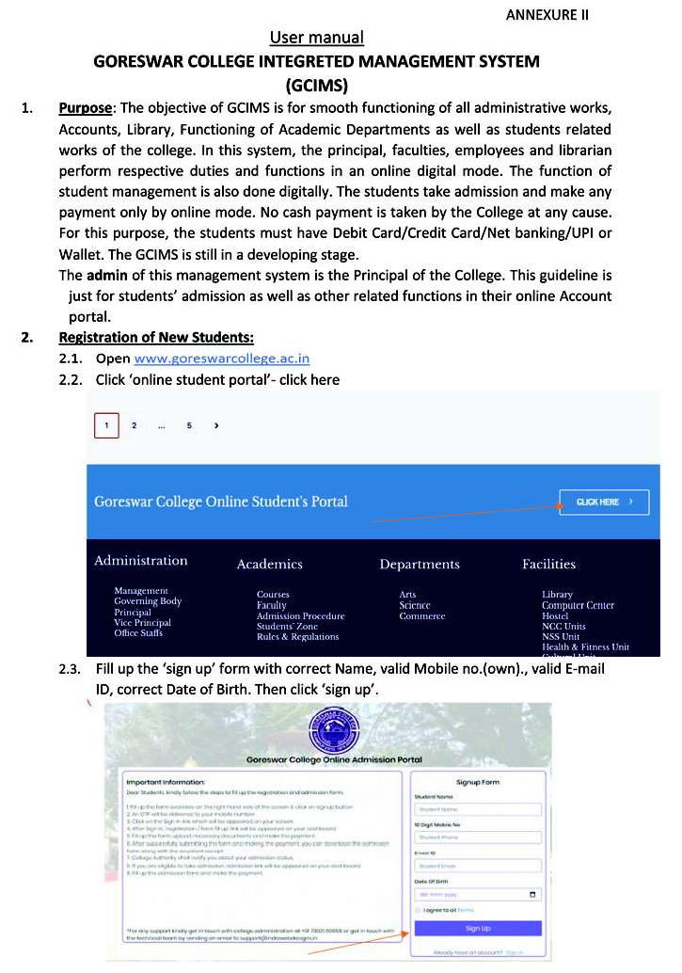

24
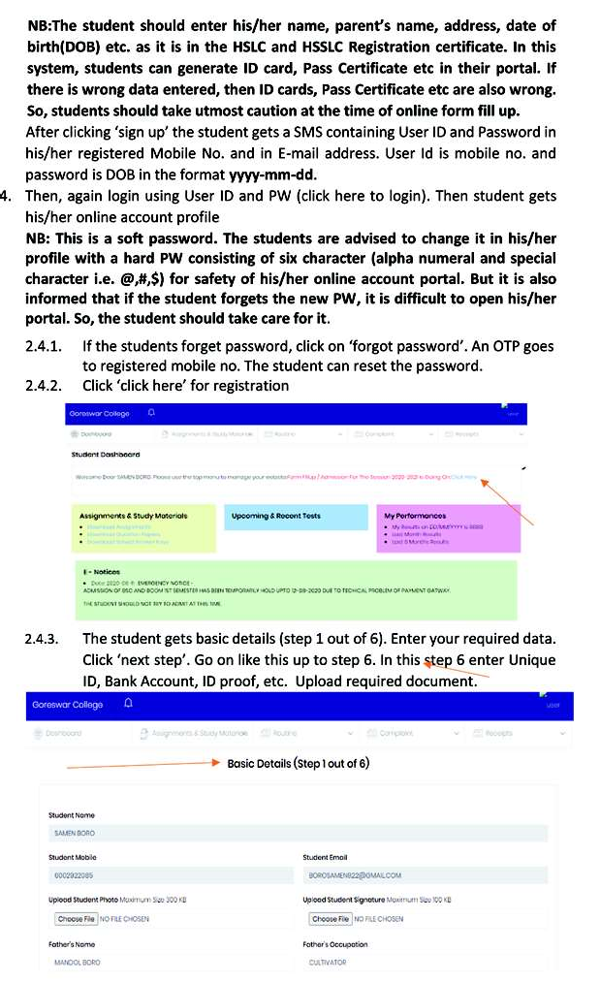

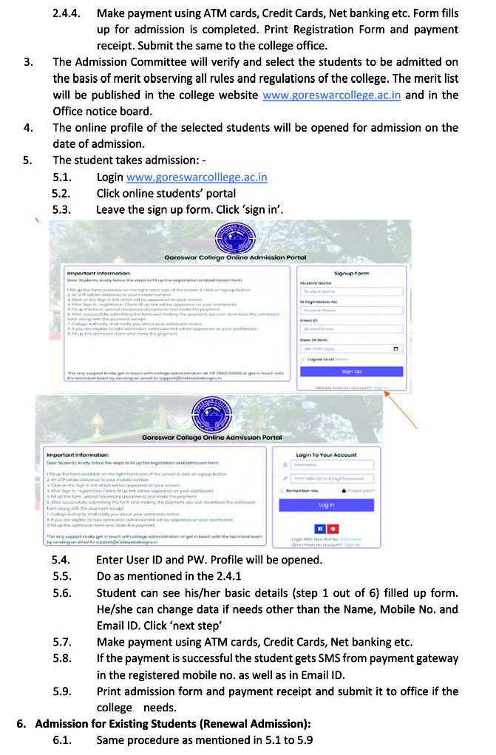
25

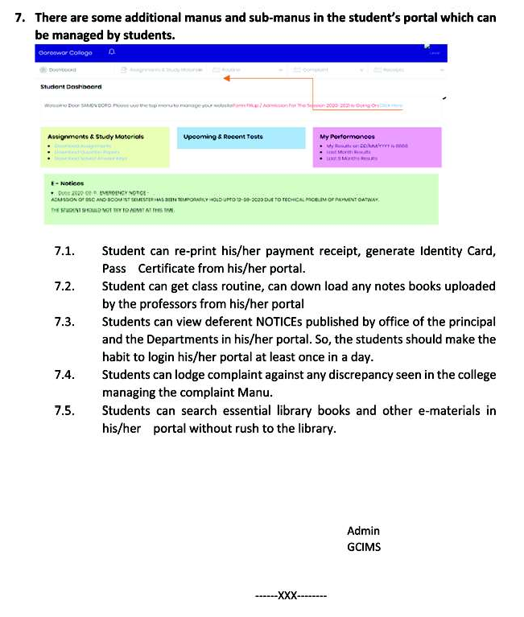

26

